TRADE OF
Pipefitting

PHASE 2

Module 4

Pipe Installation

UNIT: 1

Introduction to Pipe Installation and Safety

Produced by

In cooperation with subject matter expert:

Finbar Smith

© SOLAS 2014
Table of Contents
Unit Objective 1
Learning Outcome 2
1.0 Pipe Installation on Site 3
1.1 Safety Concerns for On Site Work 3
1.2 Guidelines to Be Observed For Safe Site Work 4
1.3 Hazardous Activities Undertaken During Pipe Installation 5
1.4 Procedures for Drilling Building Structures 5
1.5 Procedures for Working in Excavations 6
1.6 Using Permit to Work Forms 7
2.0 Hazards Associated with Piping Systems 8
2.1 Hazards Associated with Piping Services 8
2.2 Colour Coding for Piping Systems 9
2.3 MSDS Sheets 11
2.4 Tying Into a Live Piping System 13
3.0 Safety at Heights and in Confined Spaces 15
3.1 Working at Heights 15
3.2 Equipment Used for Working at Heights 16
3.3 Correct Use of a Personal Safety Harness 21
3.4 Identifying Confined Spaces and Their Hazards 23
3.5 Working in Confined Spaces 24
Exercises 26
Additional Resources 27

Unit Objective
There are six Units in Module 4. Unit 1 focuses on Introduction to Pipe Installation and Safety, Unit 2; Piping Services, Unit 3; Electricity on Site, Unit 4; Bracket Fabrication, Unit 5; Ancillary Piping Equipment and Unit 6; Piping system assembly.
In this unit you will be introduced to pipe installation on site and the safety precautions required when completing this type of work.

Module 4

Pipe Installation
Unit 1

Introduction to Pipe installation and Safety
Unit 2

Piping Services
Unit 3

Electricity on Site
Unit 4

Bracket Fabrication
Unit 5

Ancillary Piping Equipment
Unit 6

Piping System Assembly
Important Note
The following unit cannot be used as a substitute for formal safety training. Candidates must complete formal SafePass training as well as certified training and instruction for the use of specific MEWP equipment, safety equipment and confined spaces training for working in hazardous areas, as required by their employer and the laws of this land.

Learning Outcome
By the end of this unit each apprentice will be able to:
- Describe the key safety concerns associated with pipe installations on a site as opposed to working in the controlled environment of a workshop.
- List the activities of pipe installation for over ground, underground, high pressure and low pressure piping systems.
- Describe the potential hazards associated with drilling and excavating wall and floors with respect to buried or concealed services
- Identify the key requirements for permit to work forms and how to fill out a generic work permit form.
- Describe the hazards associated with the following piping systems, steam, compressed gases, water, chemicals, solvents and fuel oil.
- Describe how colour coding systems are used to identify the contents of ‘live’ piping systems.
- Describe the purpose of Material Safety Data Sheets (MSDS) and how they provide procedures for handling or working with that substance in a safe manner.
- Describe the key safety concerns with tying into a live piping system
- Describe the different types of equipment for working at heights, state their applications and describe their limitations.
- Demonstrate how to fit a safety harness and lanyard and list the pre-use safety checks to be performed before using one.
- Describe the potential hazards associated when working in confined spaces or in deep excavations and what precautions must be taken

1.0 Pipe Installation on Site

Key Learning Points
- Identify the different safety concerns when working on sites compared to working in a controlled workshop environment.
- Identify safe guidelines when working on site
- Identify typical activities completed when installing pipe work on site
- Identify the hazards associated with drilling or excavating and how to minimize them

1.1 Safety Concerns for On Site Work
Construction sites are among the most dangerous and risky working environments. Building infrastructure involves a wide array of processes, along with potentially hazardous materials and equipment, so employers have to impose construction-site safety rules in an attempt to keep accidents and mishaps from taking place. While standard safe working practices and rules still apply, working on sites exposes the individual to a complete new set of risks and hazards which are not experienced in a controlled workshop environment. Some general principals to be observed when organising work on site can be stated as follows:
- The work must be designed in such a way that any risk to life and health is avoided as far as possible and the remaining danger is minimized.
- Dangers must be combated at source and risks eliminated. PPE should only be used as a second line of defence.
- Suitable instructions and training must be given to all employees and visitors to sites.
- At all times the employer and the employee should strive to ensure that state of the art occupational medicine and hygiene and other sound knowledge according to the relevant codes of practice are taken into account.
- Work should be planed and provide with an appropriate link between available technology, work organization, other working trades and working conditions that influence the environment of the workplace.
- Individual protective measures should take second priority to the safety of the collective group.

1.2 Guidelines to Be Observed For Safe Site Work
The following are basic precautions to be observed when working on construction sites. (Please note that this is not an exhaustive list and consultation with the Site safety officer is critical before any work should commence):
- Be aware that a construction site is a changing environment and that new hazards are appearing and changing all the time.
- Pipe fitters should complete site inductions to be aware of prevailing site conditions before commencing any work
- Obey permit to work systems as site conditions may change from day to day
- The primary goal should be to eliminate the risk rather than protect against it.
- Correct PPE equipment should be worn, however this should be the second line of defence.
- Be aware of site traffic, machinery and equipment. Make eye contact with the driver and wait for a signal that is OK to proceed in mobile plants’ pathway.
- Be aware of the other trades working on site as these will have different goals to be achieved which will sometimes conflict with your goals.
- Be aware when working at heights and take appropriate safety precautions.
- Be aware when working in excavations and take appropriate safety precautions.
- Be aware when working in confined spaces and take appropriate safety precautions.
- Report all incidents / accidents no matter how minor so that other people can learn from the experience and hopefully not repeat the same mistake.
- Obey all safety signage and never assume that you know better.
- Obey the site policy on smoking and only smoke in designated areas which should be designated with proper signage.
- In the event of an emergency evacuation you should follow the pre planned procedures and report directly to your assigned muster point leaving your work place and equipment is a safe state.
- Remain at the muster point to ensure that you have been accounted for and remain there until the all clear has been given to return to the building.
- Follow instructions. Do not take chances; if you do not know, ASK., Correct or report unsafe conditions.
- Help keep the jobsite clean and orderly. Use the right tools and equipment for the job.

1.3 Hazardous Activities Undertaken During Pipe Installation
When completing work on site pipe fitters are exposed to many new hazards and hazardous actives that are not encountered while pipe fitting in a work shop environment:
- Performing hot works in explosive atmospheres (i.e. solvent or dust laden atmospheres)
- Tying into live piping systems
- Working at heights, off ladders or scaffolds
- Working in confined spaces, trenches or excavations
- Construction plant and equipment moving around site
- Working close by to suspended loads and lifting equipment
- Being exposed to buried services and or electrical cables

1.4 Procedures for Drilling Building Structures
When installing and erecting prefabricated piping, pipe fitters may be required to drill holes for bracketing support or core holes through walls to facilitate pipe routes. While large scale opes for multiple pipe runs are usually coordinated and provided by the civil contractor pipe fitters may have to complete cores for single pipe routes or drill holes to secure brackets which support pipes from floors walls or celings. When dealing with drilling or coring walls, floors or ceilings the following procedures should be observed:
- If it is suspected that hidden hazards exist at the point of penetration, relocate the work if possible.
- If the work cannot be relocated, use non-destructive testing (NDT) devices (ground penetrating radar, x-ray, magnetic, induction, conductive, or other devices and methods) to determine whether additional hazards or wall reinforcement exists.
- For hollow structures a pilot hole may be useful to look for hidden utilities.
- Area responsible person/designee, customer/requester, or other personnel consulted?
- Reviewed historical records, engineering plans, and drawings?
- Visually inspected proposed location of penetration?
- Checked other side of walls, under floors, or through false ceilings for hazards?
- NDT used to determine stud locations or if there are any services, wall reinforcement or if additional hazards exist?
- De-energized and locked/tagged-out energy sources as required?
- Non-conductive tools to be used where applicable?
- Masonry bits and hand tools to be used for initial penetration?
- Drill bits marked, fitted with stops or short drill bits (2 inches or less) to be used for solid material?
- Appropriate PPE specified and obtained?

1.5 Procedures for Working in Excavations
Pipe fitters need to be aware of the hazards of excavating or working in trenches before commencing such work. When dealing with work in trenches the following procedures should be observed:
- Contractor shall assign a competent person to all trenching and excavation work. This person shall be clearly identified to all employees assigned to the job.
- Underground lines, equipment and electrical cables shall be identified and located by the Contractor Coordinator prior to beginning work that involves.
- Contractors will not initiate work without prior approval of the Contractor Coordinator.
- Walls and faces of trenches and excavations, deeper than 1m, shall be shored, sloped or shielded as required by the type of soil encountered.
- Prior approval from the Contractor Coordinator and EH&S personnel is required before commencing, or continuing, with trenching deeper than four feet.
- A confined space entry permit shall be required where oxygen deficiency or a hazardous atmosphere exists or could exist.
- A stairway, ladder, ramp or other safe means of egress shall be located in any trench excavations more than 1m in depth.
- Daily inspections shall be conducted by a competent person for evidence of a situation that could result in possible caveins, indications of failure of protective systems or other hazardous conditions.
- Employees shall not be permitted underneath loads handled by lifting or digging equipment.
- Employees shall be protected from excavated or other materials and equipment that could cause a hazard by falling or rolling into the excavation.
- Physical barriers shall be placed around or over trenches and excavations. Flashing light barriers shall be provided at night.
Buried services are colour coded to aid identification, some of the more common colour coding is as follows:
Black or Red Electricity
Blue Water
Yellow Gas
Grey or White Telecommunications
Green Cable Television

1.6 Using Permit to Work Forms
This is a duplicate of Module 1 Unit 3 Health and safety section 6.0

2.0 Hazards Associated with Piping Systems

Key Learning Points
- Identify hazards associated with piping services
- Identify how colour coding for piping systems operate
- Identify the purpose of MSDS sheets
- Identify hazards of tying into live piping systems

2.1 Hazards Associated with Piping Services
With numerous different piping services there are numerous different hazards associated with each service. Table 1 below identifies some risks common to the following services and the method used to minimise the risk
- Steam
- Chilled water
- Compressed Gases
- Water
- Chemical / Solvents
- Fuel oil
Service | Risk | Method to minimise risk
Steam | Heat Burns | Insulation and cladding.
 | High pressure leak | High pressure pipe and fittings.  Steam gaskets.
Chilled water | Freeze Burns | Insulation and cladding.
Compressed gasses | Gas leaks | High pressure pipe and fittings.  Certified welding procedures.
 | Asphyxiation | Oxygen monitors and alarms strategically located in process areas to detect leaks
Water | Heat burns | Insulation and cladding.
 | High pressure leak | High pressure pipe and fittings.  Certified welding procedures.

Chemical / Solvents | Corrosion | Heavy wall pipe and fittings.  Special corrosion resistant alloy material e.g. stainless steel or Hastelloy.
 | Asphyxiation | Oxygen monitors and alarms strategically located in process areas to detect leaks.
 | Explosion | ATEX rated valves and instruments.  High pressure pipe and fittings
Fuel Oil | Explosion | ATEX rated valves and instruments.  High pressure pipe and fittings.
 | Excess pressure | Fit safety relief valve to system close to the system pump.  Ensure there are no valves fitted to vent lines.
Table 1 – Risks associated with piping services and methods of Risk minimisation

2.2 Colour Coding for Piping Systems
Piping systems are an important means of conveying liquids, gases, steam and air. It is however impossible to find out what a pipeline contains from its external appearance. As the number and complexity of piping systems within any facility increase, so does the need for a system to quickly and easily identify pipework, pipelines and their contents. Failure to correctly identify the service of a pipework system can and often has been shown to be the cause of plant upsets and safety incidents. Effective identification of all pipework eliminates the potential of such problems occurring. Colour coding labels can also include arrows to indicate the direction of flow.

Standards Used for Colour Coding
While different colour coding systems and standards are applicable in different countries and different industries, the following information is based on the following British standard specifications:
- BS 1710 Identification of Pipelines and Services
- BS 381C Colours for Identification, Coding and Special Purposes
- BS 4800 Paint Colours for Building Purposes
It is important that you familiarise yourself with the colour coding system that is specific to the facility that you are working in as there may be slight differences or variations that could have serious consequences if the incorrect pipe is selected by colour alone.
The Basic/Primary Identification Band (PIB) colour determines the basic type of fluid, e.g. Oil, Gas, Chemical or Water. BS 1710 suggests Basic Identification Colours for different types of fluid. BS 1710 specifies blue as the PIB colour for air, green for water, brown for oils, ochre for gases, purple for acids and alkalis, silver grey for steam, black for drainage systems and red for fire fighting systems. It should be noted that steam pipework, is generally insulated and fitted with silver coloured metal cladding.
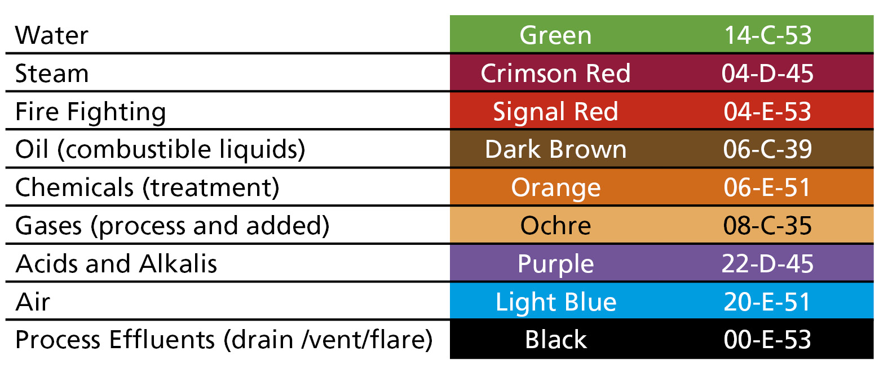
Table 2 – Basic identification colours
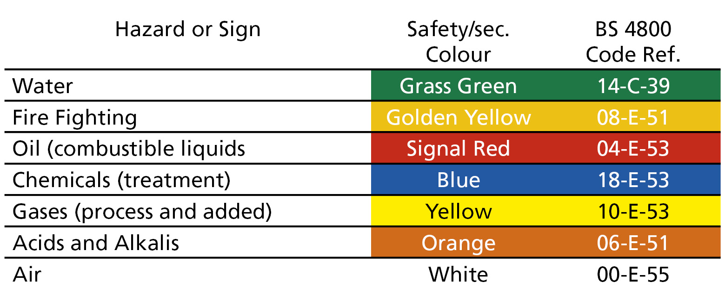
A Safety/Secondary Identification Band (SIB) colour is added to the middle of the PIB, to identify the fluid conveyed more precisely. The SIB, used in conjunction with the PIB’s, is designed to provide a unique combined Colour Code Identification Band (CCIB) for each fluid that is being conveyed.
Table 2 – Safety colours
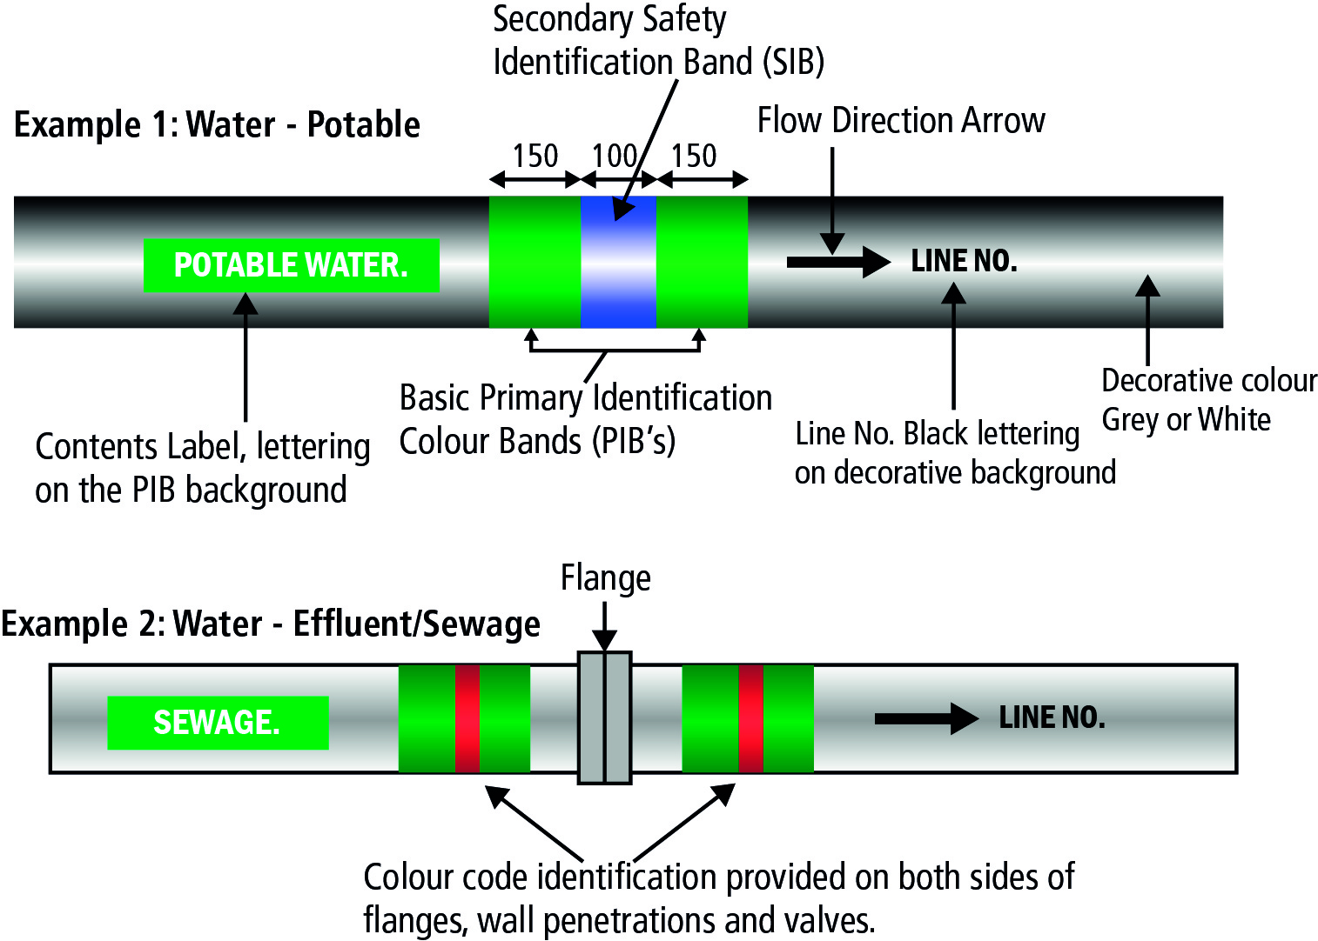
The Primary Identification Band (PIB) and the secondary Identification Band (SIB) are combined to produce a unique Three Band Colour Code Identification Band System (CCIB), as specified in BS 1710. The outer bands, which will be the same colour, are the Basic/Primary Identification Bands (PIB) and the middle band is the Safety/ Secondary Identification Band (SIB). Examples of this are illustrated in Figure 1 below.
Figure 3 – Pipework Colour Coding band layout

Advantages of Colour Coding Piping Systems
Colour coding of piping systems have the following advantages:
- It allows for easy identification of services in piping systems.
- It facilitates the tracking of lines at height from ground level.
- It is a GMP, ISO requirement.
- Colour coding is helpful for illiterates.
- Easy and accurate form of communication.
- It can reduce accidents and improve safety.

2.3 MSDS Sheets
A material safety data sheet (MSDS) is a form containing data regarding the properties of a particular substance. It is intended to provide workers and emergency personnel with procedures for handling or working with that substance in a safe manner, and includes information such as physical data (melting point, boiling point, flash point, etc.), toxicity, health effects, first aid, reactivity, storage, disposal, protective equipment, and spill-handling procedures. MSDS formats can vary from source to source within a country depending on national requirements.
In some jurisdictions the MSDS is required to state the chemical's risks, safety, and effect on the environment. There is also a duty to properly label substances on the basis of physico-chemical, health and/or environmental risk. Labels can include hazard symbols such as the European Union standard black diagonal cross on an orange background, used to denote a harmful substance.
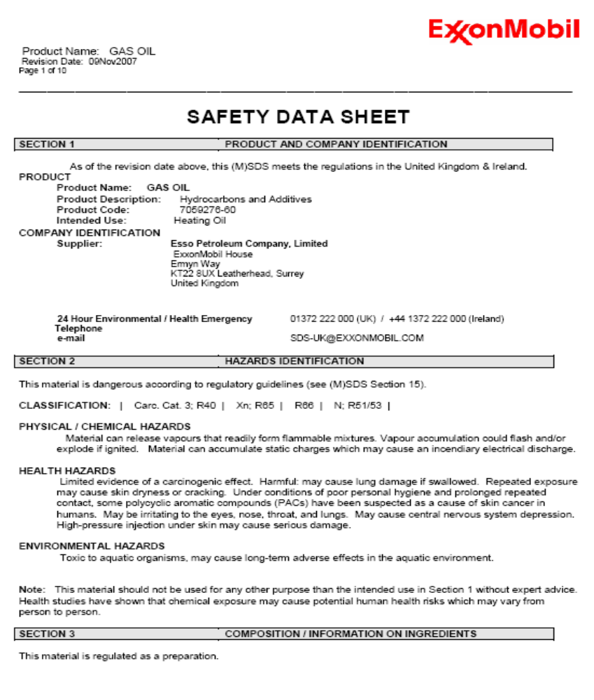
An MSDS for a substance is not primarily intended for use by the general consumer, focusing instead on the hazards of working with the material in an occupational setting. It is important to use an MSDS specific to both country and supplier, as the same product (e.g. paints sold under identical brand names by the same company) can have different formulations in different countries. The supplier must by law supply accurate MSDS sheets for any chemicals that they supply. Figure 2 below shows page 1 of a 10 page MSDS sheet for Gasoil and illustrates the typical information which they contain.
Figure 2 – Page 1 of 10 of MSDS sheet for Gasoil

2.4 Tying Into a Live Piping System
Piping tie-ins are unavoidable in plants where expansion is a current or future factor. Steam, condensate, compressed air, dust collection, vacuum and process lines are just a few types of plant piping likely to be modified by tie-ins to increase capacity. Here are a few ways to minimize costly disruption of plant operation when tie-ins are inevitable.
- Plan and schedule. New piping design should include allowances for future expansion. This can be accommodated without major expense. Consider the following:
- Increase design pipe sizes to the next larger diameter if velocity limits permit.
- Provide caps or blind flanges at the end of a pipe run where a brief tie-in outage can be tolerated.
- Provide valves with blind flanges when and where a future tie-in outage cannot be tolerated.
- Provide adequate access and maintenance space for future connecting piping.
Existing piping design may provide limited flexibility for future piping tie-in accommodations. However, take advantage of future scheduled outages and add piping flanges and valves where future tie-ins are inevitable. This will enable future construction to proceed without disrupting plant and process operations.

Completing Tie-In on Site
For precautionary reasons, issue a line break permit to address specific details of the procedure prior to construction. The purpose of the permit is to define:
- Location of the line break.
- Applicable design documents.
- Fluid in the line.
- Safety equipment requirements.
- Hazards associated with handling the materials last in the line.
- Special line washing, purging or flushing requirements.
- Valve locking and tagging requirements.
- All personnel involved or affected by the procedure.
- Installation of the connecting piping is simplified if provisions are made in the piping for isolating the tie-in point. Piping installation can then occur without disrupting the process.

“Hot Tapping”
When a tie-in point on a line cannot be isolated or the plant or process cannot be shut down to accommodate the line break, a procedure known as “hot tapping” is required. This is frequently used to break lines containing steam, natural gas, water or other utilities, which must flow uninterrupted on a daily basis. This procedure results in the installation of a lockable tie-in valve while the line is pressurized.
Figure 3 below identifies the essential equipment required for a hot tapping procedure including hot tap fitting, full open and lockable gate valve, hot tap machine (hydraulic or air-driven), cutter and pilot assembly, tapping machine housing, a power unit (hydraulic or air-driven) and hose. Basic hot tapping steps include:
- Weld the hot tap fitting onto the line.
- Install the full open gate valve on the fitting.
- Inspect and pressure test the valve and fitting.
- Install the hot tap machine on the valve.
- Bore the line.
- Retract the boring bar, then close and lock the valve.
- Depressurize the hot tap machine and remove it.
- Clean the work area.
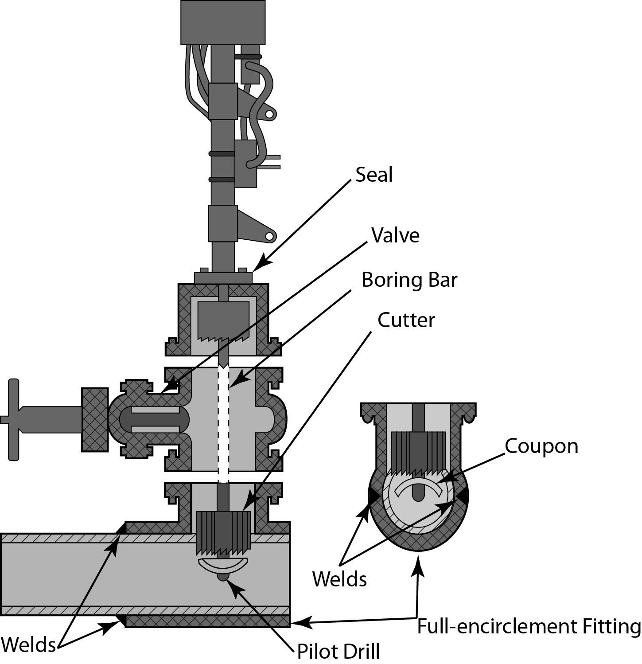
Figure 3 – Schematic of a hot tapping machine
Hot tapping is a unique, specialized procedure. Only companies experienced in this technique should be considered to perform this procedure. Often, these companies perform other tasks such as line stops, repairs, cleaning and valve replacement.
Following the hot tapping procedure, installation of connecting piping valves and fittings can proceed in much the same manner as though existing isolation provisions were already in the line. Once installation is complete, conduct a pressure and leak test of the newly installed piping with the tie-in valve remaining in the closed and locked position. With satisfactory pressure test completion, the new tie-in piping is now ready to be activated by unlocking and opening the tie-in valve.

3.0 Safety at Heights and in Confined Spaces

Key Learning Points
- Identify where working at heights occurs
- Identify how to mitigate the risks of working at heights
- Identify equipment used for working at heights
- Identify how to use a safety harness correctly
- Identify the potential hazards when working in confined spaces

3.1 Working at Heights
Work at height is work in any place, including a place at, above or below ground level, where a person could be injured if they fell from that place. Access and egress to a place of work can also be work at height.
Examples of work activities that are classified as working at height:
- Working on trestles
- Working on a flat roof
- Erecting false work or formwork
- Working on a ladder
- Working at ground level adjacent to an excavation;
- Working on formwork within an excavation
- Working near or adjacent to fragile materials
Before carrying out work at heights it is important to complete the following:
- Carry out risk assessments for work at height activities and make sure that all work is Planned, Organised and carried out by a competent person
- Follow the General Principles of Prevention for managing risks from work at height – take steps to avoid, prevent or reduce risks
- Chose the right work equipment and select collective measures to prevent falls (such as guard rails and working platforms) before other measures which may only reduce the distance and consequences of a fall (such as nets or airbags) or may only provide fall-arrest through personal protection equipment.
The Work at Height Regulations require employers to ensure that:
- All work at height is properly planned and organised
- A risk assessment is carried out for all work conducted at height
- Appropriate work equipment is selected and used
- People working at a height are competent and trained
- Equipment used for work at height is properly inspected and maintained
- Risks from fragile surfaces are properly controlled
The risk assessment should include a careful examination of what harm could be caused from working at height with a view to taking the effective steps to reduce the likelihood of this harm occurring, either through avoiding the activity or, where this is not reasonably practicable, by carrying it out in a safe manner using work equipment that is appropriate to the task and the level of risk.

3.2 Equipment Used for Working at Heights

Ladders
The Work at Height Regulations do not ban ladders but require consideration to be given to their use. They require that ladders should only be considered;
- Where the use of other more suitable work equipment such as tower scaffolds, MEWPs or temporary stairs is not appropriate, Ladders, for example, are frequently used during fit-out installations, but in most cases other work equipment is more appropriate.
- Where ladders and stepladders are used they should only be used as a work place for light work that is low risk and of short duration.
Always:
- Have 3 points of contact when using a ladder
- Make sure ladder has non-skid pads ‘Ladder Stopper’
- Test pullies, springs, rung locks and ropes on extension ladders
Do:
- Use a ladder ‘Stopper’
- Tie off top of ladder if possible
- Move the ladder
- Get a taller ladder when required
- Get down and move the ladder
- Use a Tool Belt
Don’t:
- Overreach from a ladder
- Use the top two rungs
- Move a ladder while on it
- Climb with material
- Share a ladder
- Set up near live cables.
Extension Ladders
- A minimum of 1 meter overlap is required between ladders
- Secure at the top where possible
- Area around ladder cordoned off, to keep the public safe.
- Extend ladder 1m (3 rungs) above landing place
- Follow the 4:1 rule when using extension ladders
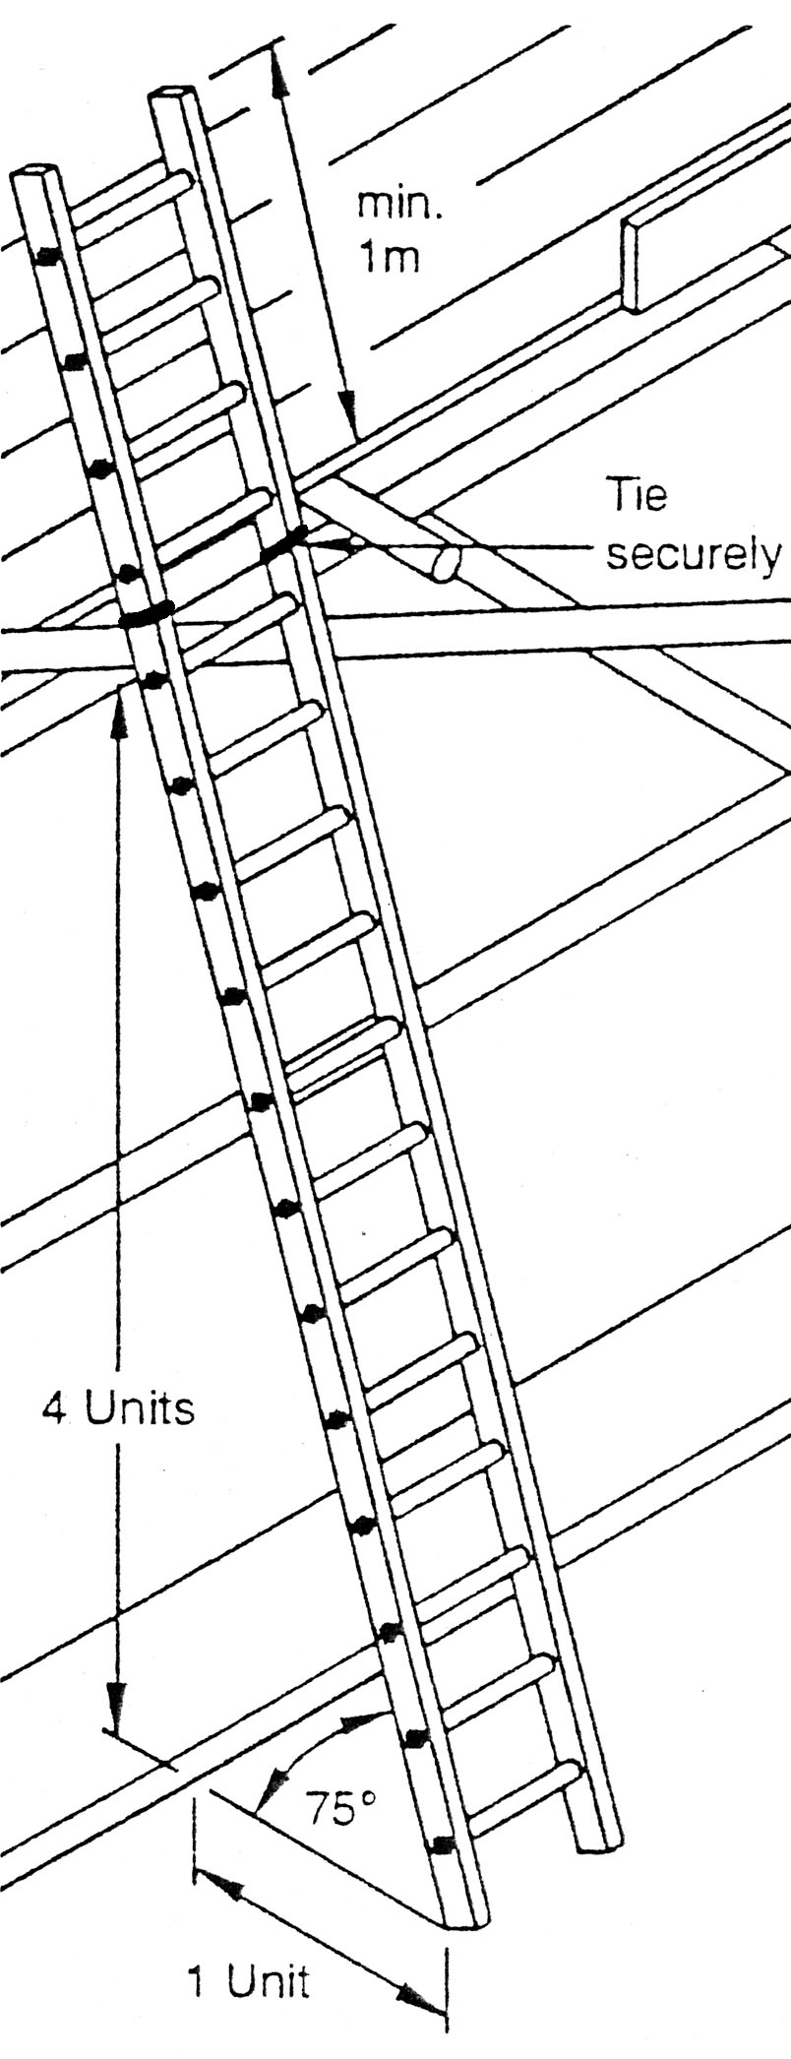
Figure 4 – Safe set-up of an extension ladder

MEWPs
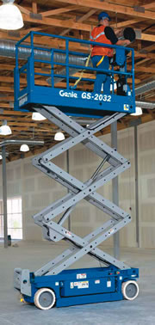
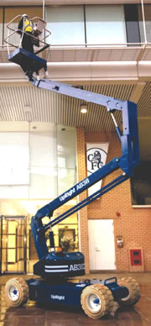
Mobile Elevated Working Platforms (MEWPs) are used to provide temporary access for people or equipment to inaccessible areas, usually at height. There are two distinct types of mechanized access platforms which are known as a "scissor lift" or a "cherry picker". They are designed to lift personnel and equipment of limited weights (usually less than a ton, although some have a higher safe working load (SWL). They are usually capable of being fully operated (including setup) by a single person.
Figure 5 – MEWPs: Scissors lift and cherry picket
Advantages of MEWPs
MEWPs have the following advantages when working at heights:
- Can be used in-doors or out
- Allow the worker to reach the task quickly and easily
- Provide a secure stable platform for personnel, materials and equipment which can be quickly moved to different locations.
Choosing the Right MEWP for The Job
If you are thinking of using a MEWP look at the following questions.
- Height; how high is the job from the ground?
- Application; do you have the appropriate MEWP for the job? (If you are not sure, check with the hirer or manufacturer.) Will the platform be used to lift equipment and materials?
- Conditions; what are the ground conditions like - is there a risk of the MEWP becoming unstable or overturning? What are the prevailing weather conditions?
- Operators; are the people using the MEWP trained, competent and fit to do so? How many people will be in the lift?
- Obstructions; could the MEWP be caught on any protruding features or overhead hazards, e.g. steelwork, tree branches or power lines?
- Is there passing traffic, and if so, what do you need to do to prevent collisions?
- Restraint; do you need to use either work restraint (to prevent people climbing out of the MEWP) or a fall arrest system (which will stop a person hitting the ground if they fall out)?
- Checks; has the MEWP been examined, inspected and maintained as required by the manufacturer’s instructions and daily checks carried out? Has the MEWP got up to date safe certification?

Scaffold
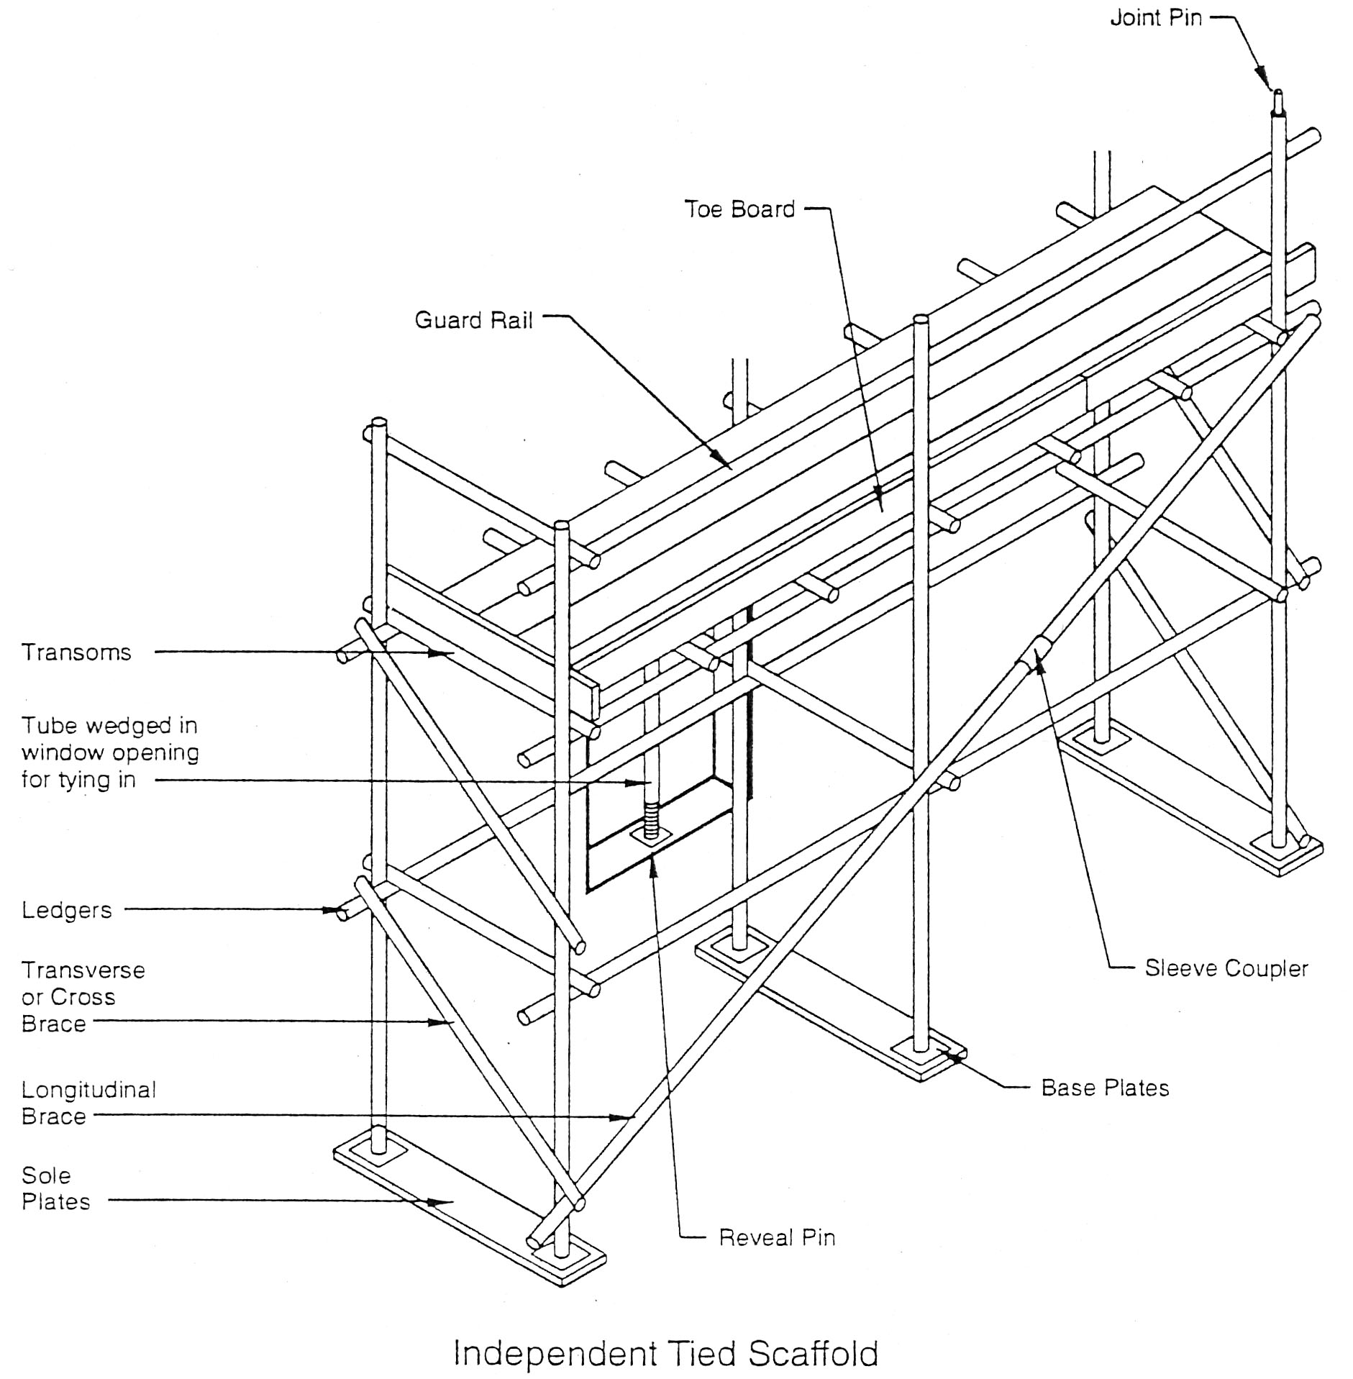
Figure 6 – Scaffolding terminology
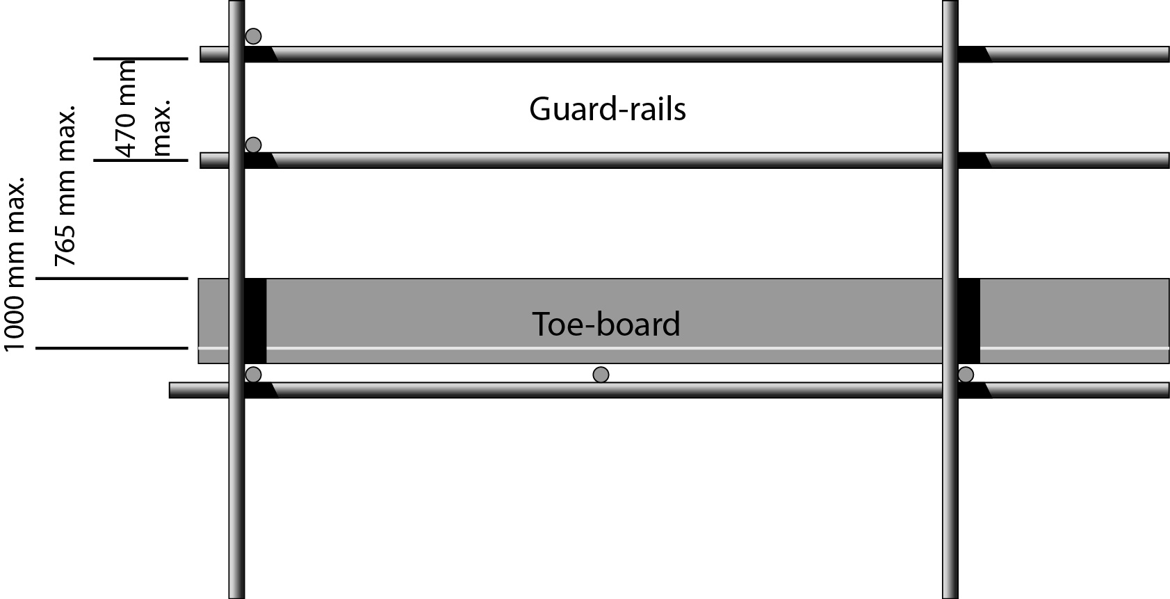
The purpose of a working scaffold is to provide a safe place of work with safe access suitable for the work being done. It is usually a modular system of metal pipes or tubes, although it can be made out of other materials.
Figure 7 – Scaffolding dimensions and terminology
When working on Scaffolding the following safety measures should be taken;
- All scaffold must be erected, altered and dismantled by competent, qualified scaffolders
- Scaffold must be inspected and tagged “Safe for use” by a competent person before using
- Ensure the working platform has close fitting boards, and has evenly supported kick boards, handrails and proper secure ladder access.
- Ensure the working platform base to height ratio is at least 3:1 external, 3.5:1 internal.
- Scaffolds shall be provided with an access ladder or equivalent safe access. Employees shall not climb or work from scaffold handrails, mid-rails or brace members.
- Foot ties should be as close to the wheels as possible.
- Swiveling castors with brakes should be secured to the uprights (keep brakes on when in use).
- Secure to a building if so required or use secure outstays.
- Check for overhead obstructions, cables, ground holes and floor obstructions when moving a scaffold tower.
- Establish an exclusion zone, work should never take place directly above other workers.
- Ensure relevant PPE is worn and fall arrest system are in place
- Good housekeeping is essential to minimize the risk of trip accidents or of objects being knocked off the scaffold onto personnel below.
- Employees shall not ride on mobile scaffolds when they are being moved.

Storage of Materials at Heights
All materials at height should be stored where they cannot fall on to workers. Work tools and materials stored at height should be kept to a minimum to minimize the risk of objects falling. Materials should be kept tidy and secure making sure that all access routes are kept clear. Working platforms should not be cluttered with stored materials, and adequate space must be maintained to allow safe access. All loose materials and waste should be removed on an on going basis.

3.3 Correct Use of a Personal Safety Harness
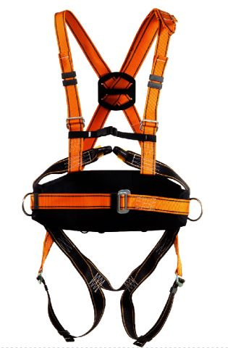
A safety harness is a form of protective equipment designed to prevent injury in the event of a fall. A safety harness should be used by anyone engaging in any activity that takes place more than 1.8m off the ground. The harness is an attachment between a stationary and non-stationary object and is usually fabricated from rope, cable or webbing and locking hardware. Safety harnesses are used in combination with lanyards which act as a shock absorber, which is used to regulate deceleration when the end of the rope is reached. While safety harnesses are designed to prevent injury, their incorrect use can actually cause harm if used improperly
Figure 8 – Full body safety harness
There are both major and minor injuries associated with the improper use of a safety harness. Some injuries which can occur with incorrect use of a safety harness can include:
- Skin lacerations,
- Muscle and bone contusions,
- Ligament sprains or tears, and cracked ribs.
- Broken bones and dislocated joints,
- Concussion, paralysis and organ damage.
- Death can occur from a broken spine or suspension trauma which can include, but is not limited to, asphyxiation or Venus pooling which is caused by a tight harness preventing proper blood circulation.
Before working at heights personnel should be trained in both working at heights and in the correct use of their safety harness. The following points should be observed before using a safety harness:
- Ensure operator is fully trained in the correct use of a safety harness.
- After a fall arrest, the equipment will no longer be used (equipment will be disposed of or destroyed)
- Clean equipment after use
- Air dry equipment, do not hang in direct sunlight
- Store equipment in a cool, dark, dry well ventilated place
- Check for frayed edges, broken fibers, pulled stitches, cuts or chemical damage.
- Check D-ring and D-ring metal wear pad (if any) for distortion, cracks, breaks, and rough or sharp edges.
- Check attachments of Buckles - Note any unusual wear, frayed or cut fibers, or distortion of buckles/D-ring. Frayed or Broken Strands - Inspect for loose, distorted or broken grommets.
- Tongue or Billet - Inspect for loose, distorted or broken grommets.
- Tongue Buckle - Check for distortion or sharp edges.
- Friction Buckle - Outer bars and center bars must be straight. Check corners and attachment points of the center bar.
Safety harnesses are used in conjunction with arrest lanyards which are a critical part of the fall arrest system. Before using a lanyard the following points should be observed:
- Be inspected prior to use
- Be protected against being cut or abraded
- Be the appropriate length (max 2 M) and never longer than the distance a person could fall.
- Be attached to a secure anchor point not to itself or a movable object such as a ladder.
- Sufficient clearance must be available
- Never tie knots in lanyards
- After a fall, the lanyard should no longer be used (equipment should be disposed of or destroyed)

Causes
Human error in the improper use of a safety harness is almost always the cause of safety harness injuries. Not having the harness properly adjusted or secured to your body can cause the safety harness to slip or fail in the event of a fall. Leaving too much slack in the attaching lanyard or strap can create an abrupt stop during a fall and cause you to experience a violent jerk to your body. Too much slack can also allow the lanyard to become tangled in nearby equipment, causing it to tighten around your body.

Survival
If you experience a fall, the longer you hang suspended in the air by the harness, the less chance you will have of climbing to safety. If you do experience a fall it is imperative that you do whatever is necessary to right yourself as soon as possible as you may only have a few minutes before you lose consciousness. The weight of your body hanging motionless in the harness for longer than five minutes can cause your chest to become compressed, restricting your lung function, causing you to pass out and be asphyxiated.

Prevention
The best way to avoid safety harness injuries is by matching the proper harness to the activity and having it properly adjusted. Allow as little slack in the attaching strap as possible, barely enough to allow you just enough room to be able to execute your activities. That way if you should slip, your fall will be as short as possible. A full body harness with padding is the safest as it will distribute the force of the fall most evenly across your body, rather than focusing it in just one or two areas. If you haven't used a safety harness before it is advisable to receive instruction on the prevention of safety harness injuries.

3.4 Identifying Confined Spaces and Their Hazards
Pipe fitting and welding are hazardous activities at the best of times when carried out in the controlled environment of a workshop. The risks that these activities poses, increase and multiply many times when they are carried out in confined spaces. Confined spaces are not limited just to vessels are defined by the HSA as:
Any place, including any vessel, tank, container, vat, silo, hopper, pit, bund, trench, pipe, sewer, flue, well, chamber, compartment, cellar or other similar space which, by virtue of its enclosed nature creates conditions which give rise to a likelihood of accident, harm or injury of such a nature as to require emergency action due to:
- The presence or reasonably foreseeable presence of:
- flammable or explosive atmospheres,
- harmful gas, fume or vapour,
- free flowing solid or an increasing level of liquid,
- excess of oxygen,
- excessively high temperature.
- The lack or reasonably foreseeable lack of oxygen.
The HSA also states that
The following are key characteristics of a 'confined space' for the purposes of their Code of Practice.
- The space must be substantially enclosed.
- There must be a risk of at least one hazard of the type, listed in the definition above, occurring within the space.
- The risk of serious injury from the hazard must be created by virtue of the enclosed nature of the space.
- The potential injury must be serious and be such as to require emergency action to rescue the person involved.
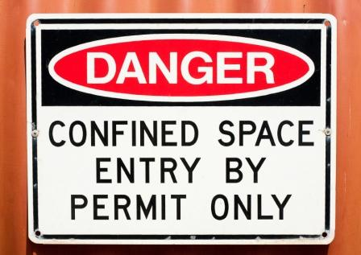
Entry to confined spaces should be marked and identified as per figure 3 below.
Figure 9 – Confined space warning sign
Additional hazards that the pipefitter faces when working in confined spaces are as follows:
- Asphyxiation due to a build up of fumes in confined spaces
- Possibility of fire or explosion from remnant vapours remaining in the confined space
- Actual or potentially hostile environment, (e.g. working in a vessel with an agitator or other moving parts)
- Increased exposures to metal fumes and non-ionizing radiation
- Burns and eye damage caused by excessive reflection when working in confined spaces.
- Biological hazards (e.g. Weil’s disease transmitted by rodents)

3.5 Working in Confined Spaces
Before commencing work in a confined space the following points should be enforced:
- If the work must be carried out Hazard Identification and Risk Assessment must be carried out prior to the work commencing
- Method statement prepared for the work to be completed to be approved by a competent supervisor and signed off by all involved in the activities.
- Only trained personnel should be allowed enter a confined space
- Check for flammable or toxic gases
- Check for percentage of O₂ present
- Wear correct PPE required for the task
- Ensure there is adequate ventilation or breathing apparatus if required
- Ensure ventilation equipment exhausts down wind of the fresh air inlet or point of entry
- Ensure there is a hoist and an operator capable of winching the dead weight of the person from the confined space. (See figure 3 below)
- Ensure there is adequate provision for rescue personnel if required in case of emergency.
- Do not attempt a rescue without first raising the alarm and wearing breathing apparatus.
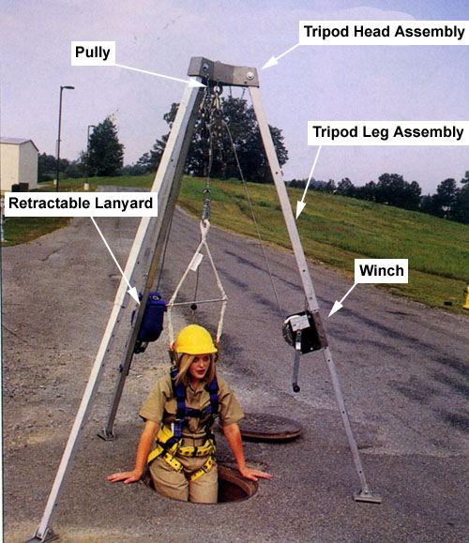
- The first duty of any rescuer is to ensure their own safety
- Leave a confined space as soon as you are told to do so.
Figure 10 – Safety winch for extraction of operator from confined spaces

Exercises
- Complete Work Permit form as per Exercise No.2.4.1
- Demonstrate how to correctly assemble and fit a safety harness
- Identify 5 hazards that are present on a construction site that would not be present in a workshop

Additional Resources
Title | Author | Ref. Code
Avoiding danger from underground services | HSE  2000 | ISBN  9780717617449
The Induction Book, “Code of Behaviour & Health & Safety Guidelines” | SOLAS
Basic Welding and Fabrication | W Kenyon | ISBN 0-582-00536-L
Fundamentals of Fabrication and Welding Engineering | FJM Smith | ISBN 0-582-09799-1
Workshop processes, practices and materials, 3rd edition, Elsevier Science & Technology | Black, Bruce J 2004 | ISBN-13: 9780750660730
New Engineering Technology | Lawrence Smyth & Liam Hennessy | ISBN 086 1674480

Videos
- Understanding welding fumes
- Welder on Site…Be Aware (Vocam)
- Powered hand tool safety (Vocam)
- Industrial Ergonomics (Vocam)
Available from:
Vocam Ireland
Circle Organisation Ltd
Friar Street, Thurles, Co Tipperary, Ireland
Tel: +353 504 24666

Castleforbes House
Castleforbes Road
Dublin 1

